Practical - 10
Practical Title: Secure Login/Logout with Sessions, Role-Based Access, Timeout, and Remember-Me Token
Develop secure login and logout functionality using PHP sessions. Verify
password using password_verify(), regenerate session ID after login,
restrict dashboard access, implement role-based redirection, session
timeout, and optional secure remember-me token.

Theory
1. Are sessions started and destroyed securely?
Yes, user sessions are initialized safely using session_start() and completely cleared upon logout by destroying session data and unsetting session variables.
2. Is password_verify() used correctly?
Yes, authentication verifies incoming plain-text passwords against stored database hashes using password_verify() for secure login validation.
3. Is unauthorized dashboard access blocked?
Yes, access control checks exist on protected pages to verify active session variables, redirecting unauthenticated users back to the login page.
4. Is session timeout implemented?
Yes, session expiration tracking automatically invalidates idle sessions after a set period of inactivity to maintain account security.
5. Are admin and student users redirected to appropriate dashboards?
Yes, role-based redirection checks user privileges upon successful login and routes students and administrators to their respective dashboard interfaces.

Output
- Implemented secure session management with proper initialization, authentication checks, and explicit logout destruction routines.
- Verified user login credentials safely by comparing hashed passwords and enforcing strict role-based route access controls.
- Protected dashboard endpoints against direct URL access and added automated session timeouts for inactive user instances.
To View Code: https://github.com/shreyajodhani/studenthub.git

Evidence of Work (Screenshots)
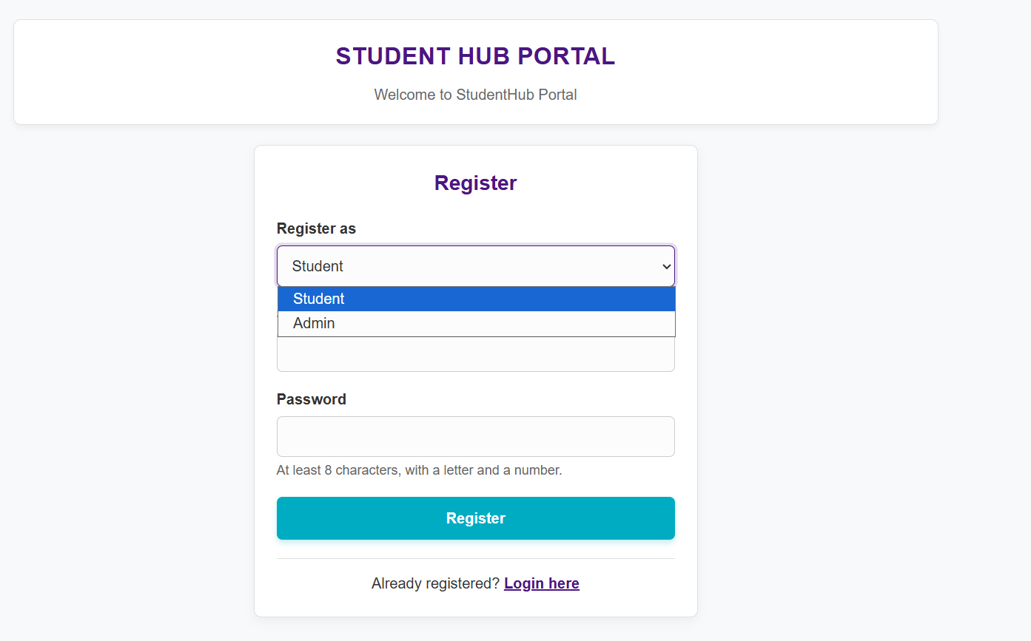
Description: option to login as a student or admin.

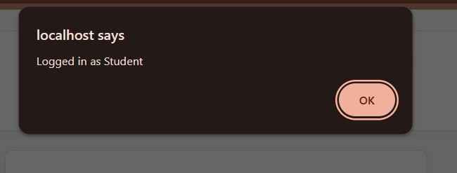
Description:
Logged in as a student.

GitHub Repository Link: https://github.com/shreyajodhani/studenthub.git

Challenges Faced:

To implement session code perfectly

Learning Outcomes:
Add session timeout.
Faculty Remarks: (Keep this blank for faculty)

